Mathematics: Units 2A and 2B
Formula sheet

Number and algebra: Functions and graphs

y = mx + c, where m = gradient; c = y - intercept

Space and measurement: Measurement

In a right triangle: 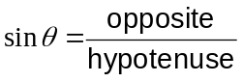 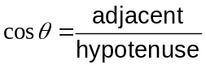 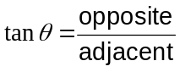
Pythagoras’ Theorem:
In a right triangle ABC, where a, b are the short sides; and c is the hypotenuse, 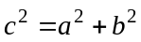

Circle: 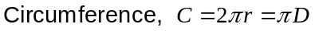
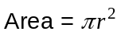
Triangle: Area = × base × perpendicular height
Parallelogram: Area = base × perpendicular height
Trapezium: Area = 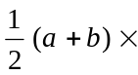height, where a and b are the lengths of the parallel sides
Prism: Volume = Area of base height
Cylinder: Total surface area = 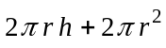
Volume = 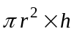
Pyramid: Volume = area of base height
Cone: Total surface area = 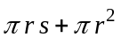, s is the slant height
Volume = 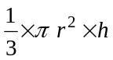
Sphere: Total surface area = 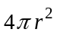
Volume = 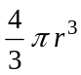

Space and measurement: Coordinate geometry

Gradient of line, m, through the points 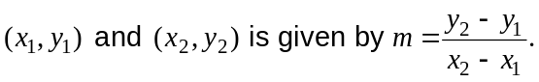

Distance, d, between the points

Note: Any additional formulas identified by the examination panel as necessary will be included in the body of the particular question.

